# What He Really Thinks Dating Cardgame

# Objective

What He Really Thinks is a Multiplayer card game in which two players play against each other with Player 1 sharing a room code with Player 2.

**SOURCE CODE**

Ideally I would like the game in an Android iOS application using Unity technology. The source code is available at

<https://drive.google.com/file/d/1UkaI7LI4y39_rRfTIadrOpe1aSk-_91b>

# Flow Chart

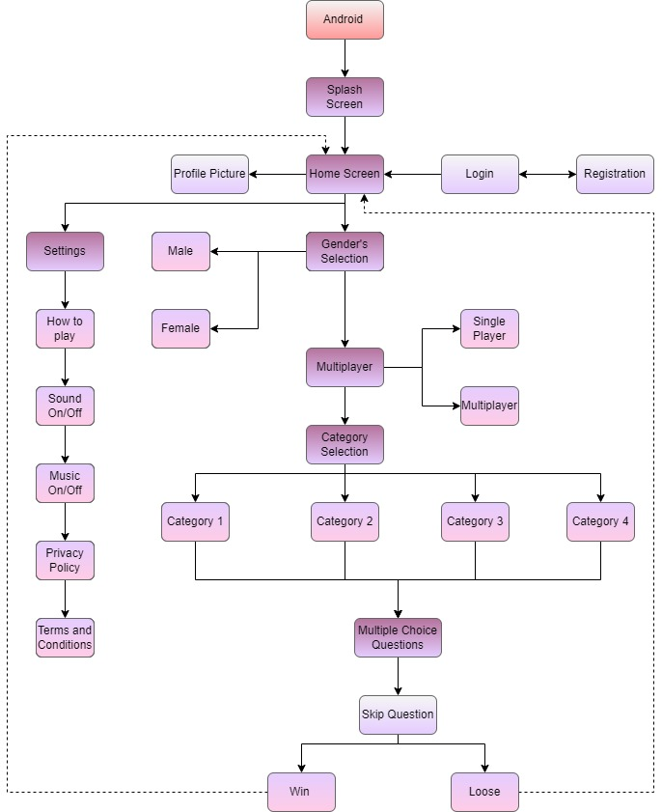

# Scope of Work

# Project Features:

1. **Splash Screen/Loading Screen**

* Once User downloads the game this will be the first screen that will appears for a short time when the user click on the game icon to play the game.
* It will contain a game logo and game theme base background.

1. **Signup Screen**

Users will have to register on the platform when they download the game by entering the following details:

First name

* Last Name
* Email
* Gender Selection
  + Male
  + Female
* Password
* Confirm Password

1. **Login**

Users have to have to fill following details to login into the game.

* Email Id/Username
* Password

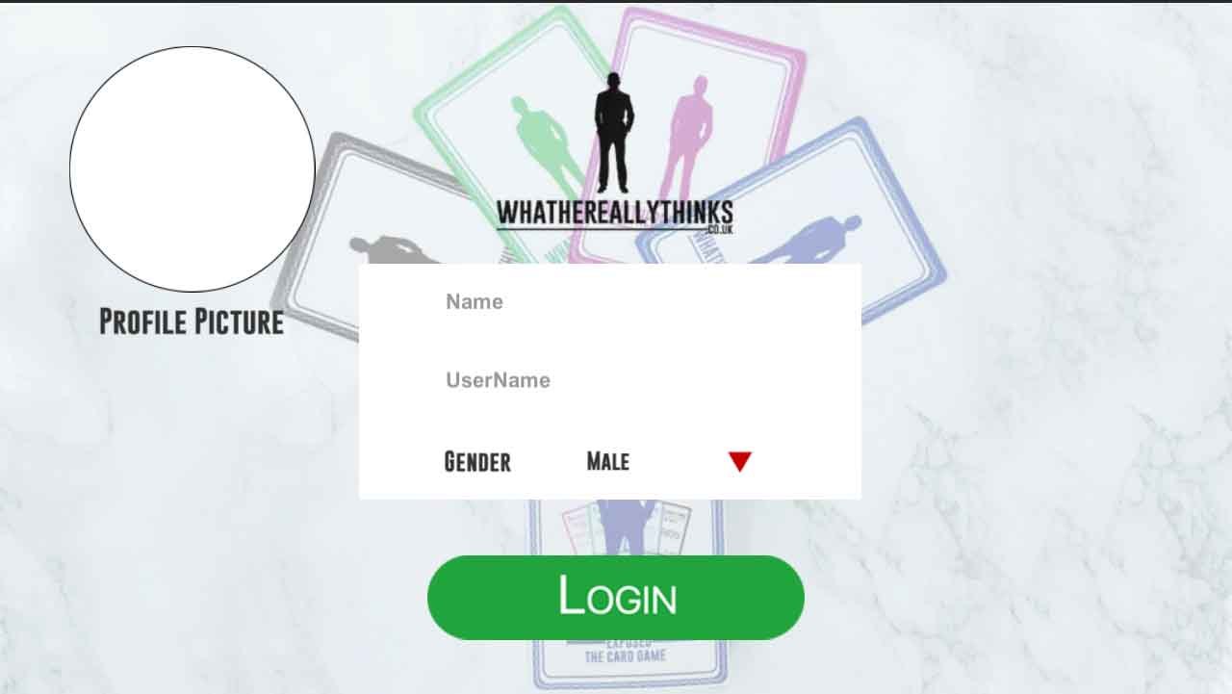

1. **Forget Password**  
   If users forgot their password they will have the option to retrieve his/her password then the user will enter the new password and confirm it.
2. **HomeHome & Menu Screen**

* Once the user logs in, the user will redirect to the home screen.
* Home Screen would be the main screen of the game from where the user will navigate into the game
* Users will see Play with friends, Settings, and exit options on the home screen.**Home**

1. **Profile section & profile update**

User can easily edit/update their profile name and profile picture.

1. **Play with Friends**

* Users have the option to select the option to ‘Play with A Friend’, then they need to then send an invitation code to their Friend
* After entering the code, the game will start

1. 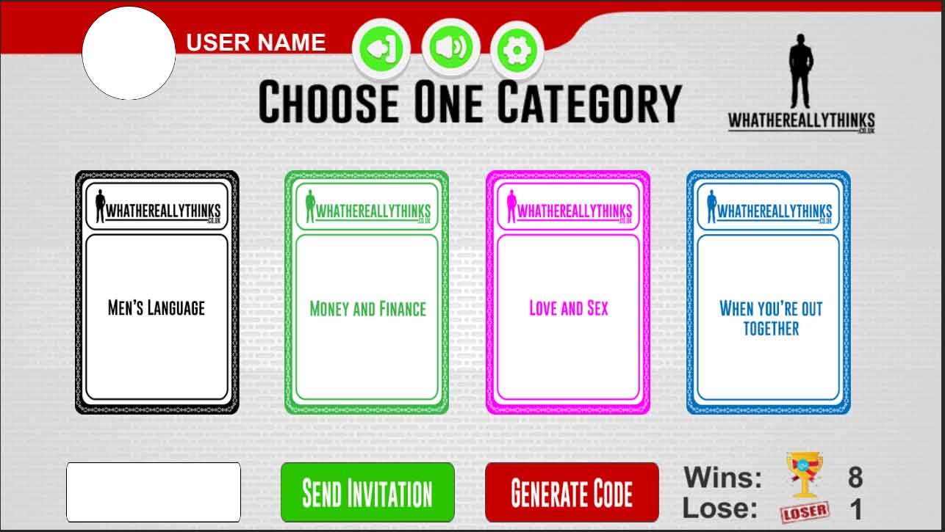**Category Selection**

* Four categories will be displayed on the screen, Player 1 has to select anyone to start the game. According to the chosen category questions would be asked.
* There would be four categories players have to select any one category, then the number of questions appear according to the category selected by Player 1. Both players have to keep answering all the displayed questions, or choose to skip questions. Once a player has answered a question a green light will appear above their name to indicate they have answered.
* After all the questions are answered in the category, there’s a score board that will show the scores of the players.
* Players have the option to skip the questions If they don’t want to answer it and will go ahead for further.
* Once a player has answered a question a green light will appear above their name to indicate they have answered.

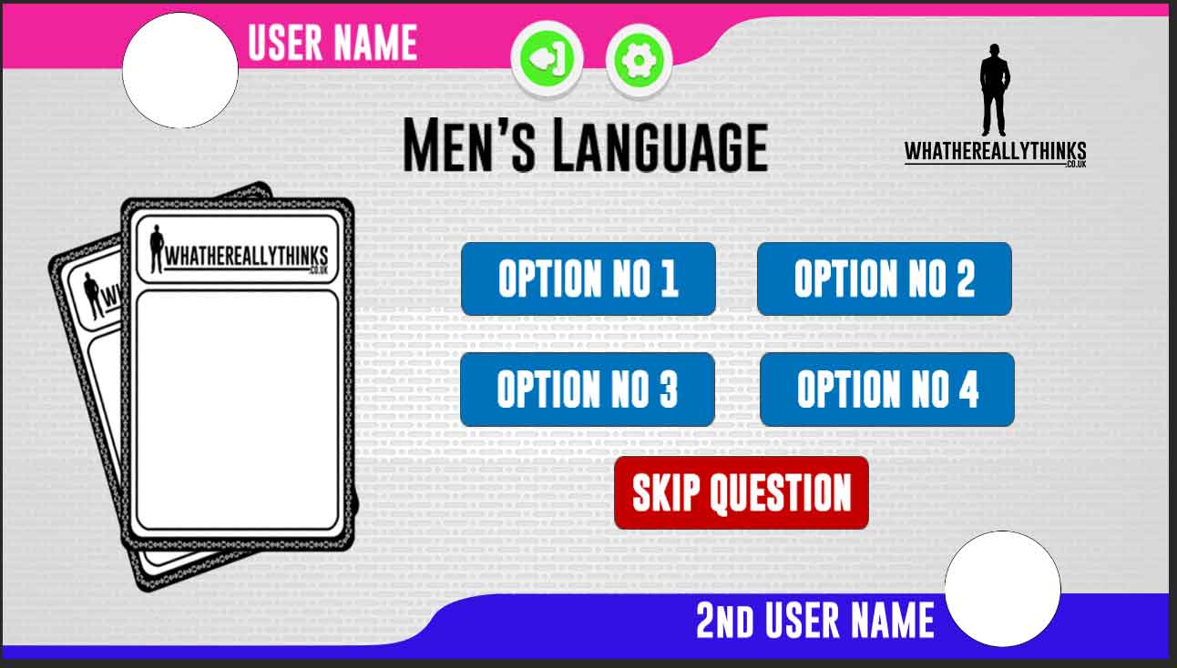

1. **Leader Board**

* After all the questions are answered in the category, there’s a score board that will show the scores of the players. If the answers from Player 1 correctly matches the answers of Player 2, then Player 1 wins a point. It the answers do not match then Player 2 wins a point.

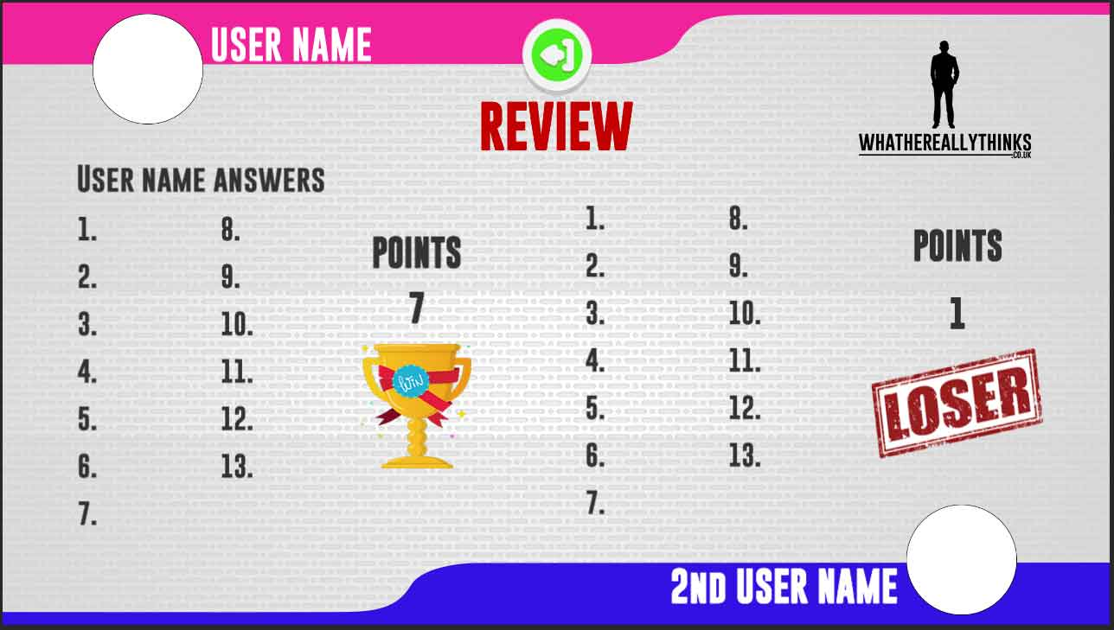

1. **Settings**

* Users can ON/OFF game sounds from here.
* Users can do music ON/OFF
* Terms & condition
* Privacy Policy.
* Info